**WEB TECH QUIZ**

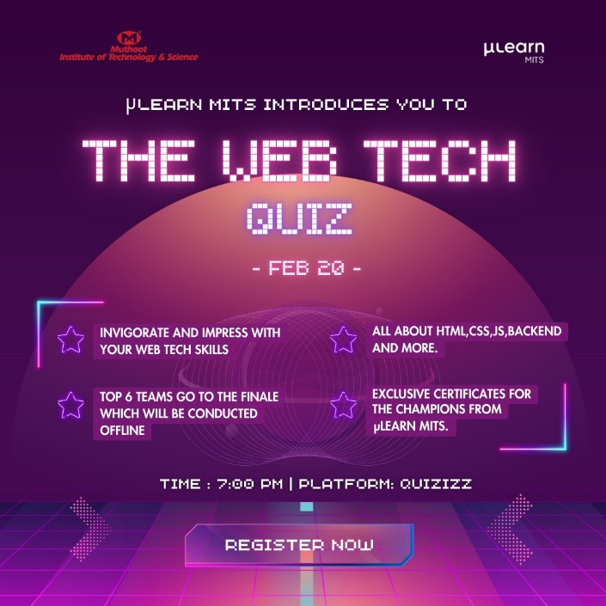

The WEB TECH QUIZ is a quiz designed exclusively to test the web development knowledge in HTML, CSS , JavaScript, Backend Development, Web Security and Tech Stacks. The quiz was conducted in 2 rounds: Preliminary and Final round. Winners will receive certificates from Mulearn MITS.

**PYTHON WORKSHOP**

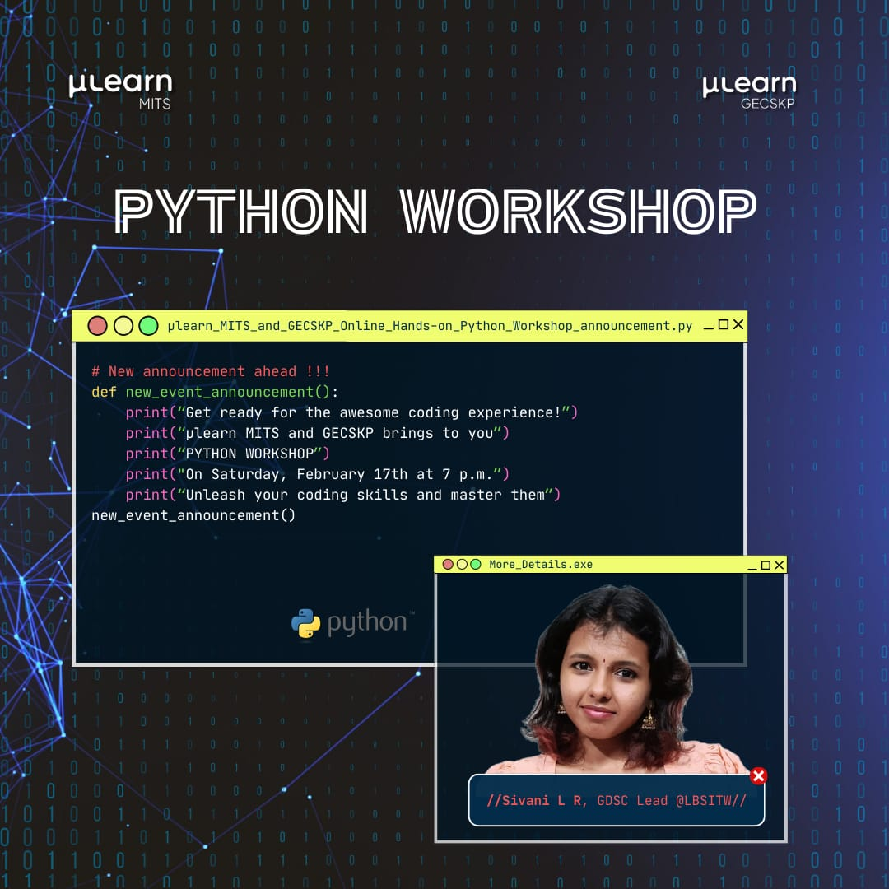

A handson python workshop was conducted on 17th February 2024 .This workshop was led by Sivani LR, GDSC Lead at LBSITW. The Python Programming Workshop is a great way to jumpstart your journey in the world of coding. Through this workshop, participants will gain an understanding of the core concepts of programming and how they can be applied to solve real-world problems.

**SALT MANGO TREE**

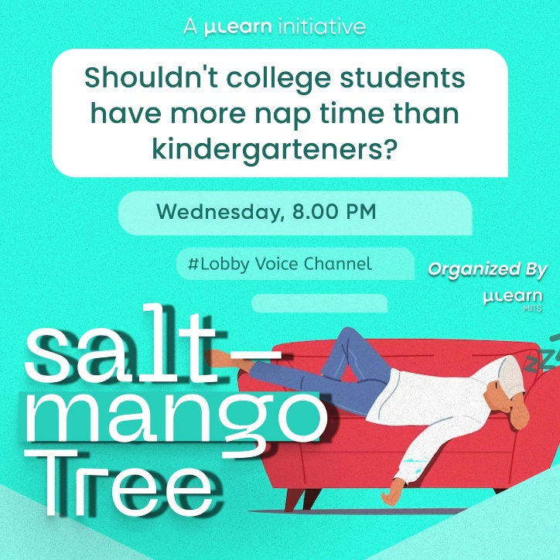

Salt Mango Tree is a group discussion on a given topic, aimed at developing speaking skills.It was held on 7th Febrauary 2024 through Gathering Field Voice Channel.

Speaking a language is a skill, like driving a car, playing a musical instrument or learning to swim. To be a good driver, you need to practise driving. You can read a book about car mechanics. You can study the rules of the road. But nothing is as good for your driving as spending time behind the wheel of a car, actually driving. It's the same with speaking English. No matter how much you study grammar and vocabulary, if you don't practise spoken communication, it's very difficult to get good at it.

**COMPETITIVE CODING**

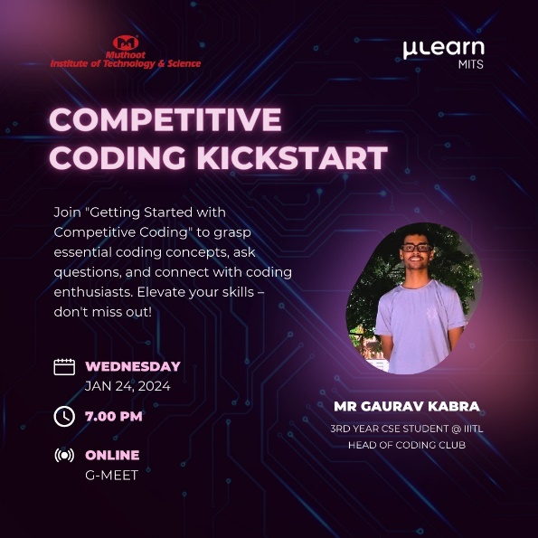

The Competitive Coding Session was led by Mr.Gaurav Kabra, Head of Coding Club at IIIT Lucknow. Competitive Coding session provided an opportunity to know more about coding concepts, ask doubts, solve coding challenges and connect with coding enthusiasts. This session helps to build a strong foundation in data structures and algorithms. This knowledge is crucial for efficient coding.

**WEEKLY TWITCH**

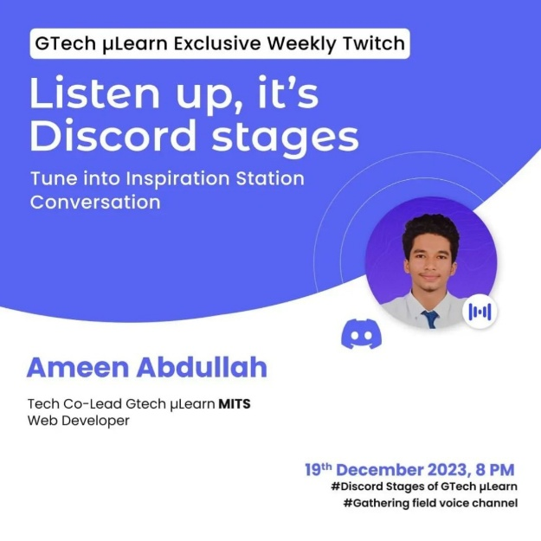μLearn Inspiration Station Radio is a place where positivity is attained from the inspirational experiences of people. An edition of the event was hosted by μLearn MITS on 19th September 2023 via Discord. Ameen Abdullah, Web Developer and μLearn MITS Tech Co – Lead was the speaker, who took the listeners on a motivating journey by sharing his success in the domain of Web Development.